Bank Management System

**PROJECT REPORT**

Submitted by

Gurditya Khurana[RA1911003010572]

Sneha Ghosh [RA1911003010630]

Date: 21/04/2022

TABLE OF CONTENTS

| CONTENTS | PAGE NO. |
| --- | --- |
| ABSTRACT | Page-2 |
| ACKNOWLEDGEMENTS | Page-3 |
| INTRODUCTION | Page-4 |
| DESCRIPTION | Page-4 |
| PROJECT OBJECTIVES | Page-5 |
| PROJECT SCOPE | Page-6 |
| DIAGRAM | Page-7 |
| FEATURES | Page-7 |
| MODULES | Page-8 |
| WORKING MODEL DESCRIPTION & RESULT | Page-9-43 |
| REFERENCES | Page-44 |

ABSTRACT

The bank management system project is a program that keeps track of a client’s bank account. This project demonstrates the operation of a banking account system and covers the essential functions of bank management software. It develops a project for resolving a customer’s financial applications in a banking environment to meet the needs of an end banking user by providing multiple ways to complete banking chores. Additionally, this project is to provide additional features to the user’s workspace that are not available in a traditional banking project. The project’s bank management system is built on cutting-edge technologies. This project’s main goal is to create software for a bank account management system. This project was designed to make it simple and quick to complete previously impossible processes with manual systems which are now possible with this software.

ACKNOWLEDGEMENTS

I would like to express our team’s warm gratitude to our guide, Mrs. Ms.B.Sowmiya for her valuable guidance, consistent encouragement, personal caring, timely help and providing us with an excellent atmosphere for doing research. All through the work, in spite of her busy schedule, she has extended cheerful and cordial support to me for completing this research work.

INTRODUCTION

The Bank Management System (BMS) is a web-based tool that is used to reimburse financial institutions for services rendered to the Bureau of the Fiscal Service. In addition, BMS provides analytical tools for reviewing and approving salaries, budgets, and outflows.

DESCRIPTION

This project has been developed to carry out the processes easily and quickly, which is not possible with the manuals systems, which are overcome by this software.

Creating and managing requirements is a challenge of IT, systems and product development projects or indeed for any activity where you have to manage a contractual relationship. Organization need to effectively define and manage requirements to ensure they are meeting needs of the customer, while proving compliance and staying on the schedule and within budget. The impact of a poorly expressed requirement can bring a business out of compliance or even cause injury or death.

Requirements definition and management is an activity that can deliver a high, fast return on investment. Thus, above features of this project will save transaction time and therefore increase the efficiency of the system.

Project Objectives

The goal of the bank management system project is to create an organic and optimal software of interaction between the various banking components. This is to maximize the profit of the banking mechanism. The implementation of competent bank management procedures is significantly responsible for the successful optimization of the bank’s productivity and activities.

The project’s main goal is to create an online banking system for banks. All banking work is done manually in the current system. To withdraw or deposit money, the user must go to the bank. Today, it is also hard to find account information for people who have accounts in the banking system.

Project Scope:

Depending on the bank’s policies, bank personnel and/or customers can utilize the Banking Management System. It can be utilized by multiple employees at the same time if they have the necessary permissions. Any web browser with a graphical interface can be used to access it.

Bank Management System ER Diagram:

The ER diagram for the bank management system was made based on bank requirements. It can encode customer information and banking transactions.

The admin can have access to the customer status and information for the important transactions. They can handle the data needed in managing customer and employee files as well as the transactions made by the customer and staff.

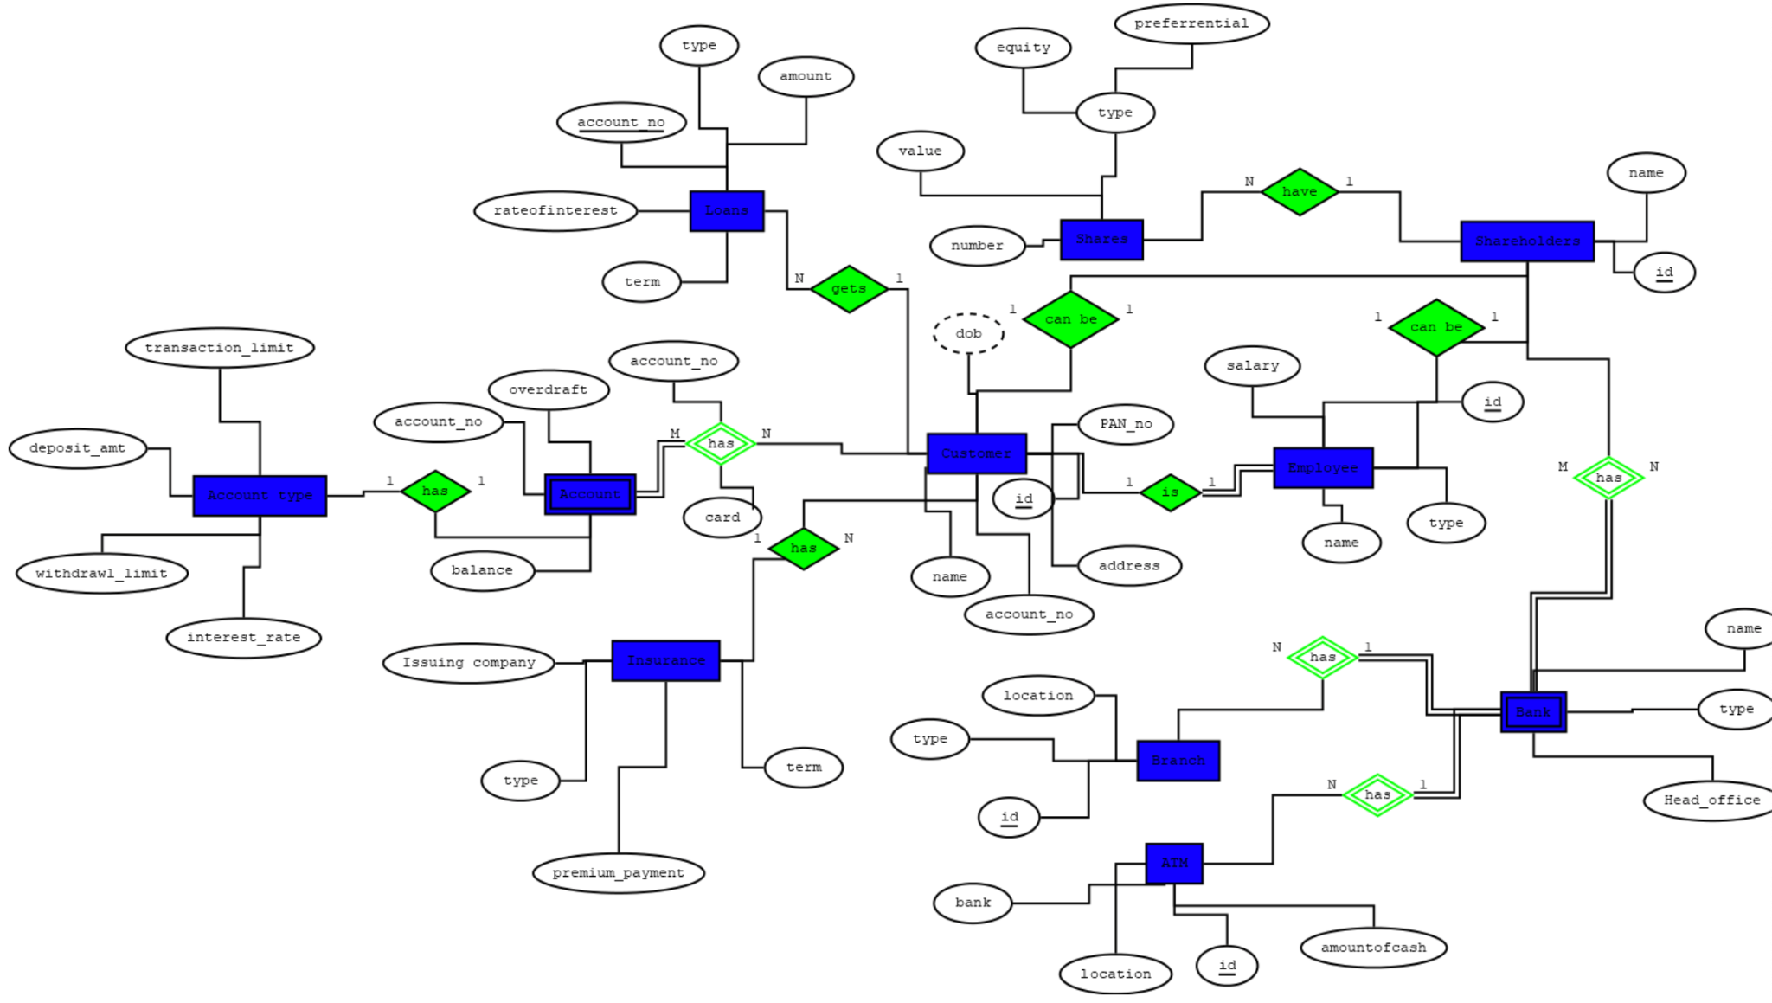

Features of Banking Management System

* User can search details of the Accounts, Balance, Customer, Employees
* Banking Management System is an online application, from which user can easily manage Balance details, Saving Account details, Current
* Account details
* Admin can track all the information of Balance, Accounts, Saving Account ect
* Admin can edit, add, delete and update the records of Current Account, Customer, Employees
* Manage the information about of Saving Account, Customer, Balance

Modules of the Banking Management System

* These are the main modules of the project:
* Balance Module : We can create, read, update and delete Balance from this module
* Accounts Module : All the operations related to Accounts, is managed by this module
* Saving Account Module : Saving Account Module is used to manage the Saving Account
* Current Account Module : It has been developed for managing the Current Account
* Customer Module : It manages the Customer
* Employees Module : Employees operations will be managed by Employees module

WORKING MODEL DESCRIPTION & RESULT

Code:

DROP TABLE customer;

DROP TABLE Employee;

DROP TABLE Insurance;

DROP TABLE Loans;

DROP TABLE Shares;

DROP TABLE Shareholders;

DROP TABLE Branch;

DROP TABLE ATM;

DROP TABLE Bank;

DROP TABLE Account;

DROP TABLE Cust_has_account;

DROP TABLE Bank_has_s_holders;

CREATE TABLE Customer(c_name varchar(20) NOT NULL,

c_id varchar(20) PRIMARY KEY,

c_acc_number varchar(20) NOT NULL,

c_dob varchar(20),

c_shareholders_id varchar(20) UNIQUE,

c_pan_no varchar(20),

c_address varchar(100) DEFAULT 'Bangalore');

CREATE TABLE Employee(e_name varchar(20) NOT NULL,

e_type varchar(100),

e_salary integer,

e_emp_id varchar(20) PRIMARY KEY,

e_sh_id varchar(20) UNIQUE,

e_cust_id varchar(20),

CHECK(e_salary>0));

CREATE TABLE Insurance(i_issuing_company varchar(20) DEFAULT 'HDFC Standard Life',

i_type varchar(100),

i_premium_pay integer,

i_term integer,

i_policy_no varchar(10) PRIMARY KEY,

i_custo_id varchar(20),

CHECK(i_premium_pay>0));

CREATE TABLE Loans(l_account_no varchar(20) PRIMARY KEY,

l_type varchar(100),

l_amount integer,

l_term integer,

l_rate integer DEFAULT 6,

l_cust_id varchar(20),

CHECK(l_amount>0));

CREATE TABLE Shares(s_number integer PRIMARY KEY,

s_value integer,

s_type varchar(100),

s_shold_id integer);

CREATE TABLE Shareholders(sr_id varchar(10) PRIMARY KEY,

sr_name varchar(20),

sr_custt_id varchar(20));

CREATE TABLE Branch(b_id varchar(10) PRIMARY KEY,

b_type varchar(100),

b_location varchar(40) NOT NULL,

b_bank_name varchar(20));

CREATE TABLE ATM(a_id varchar(20) PRIMARY KEY,

a_location varchar(20),

a_cash_amt integer,

a_bank_name varchar(20));

CREATE TABLE Bank(bk_name varchar(20),

bk_type varchar(20),

bk_head_office varchar(20),

bk_branch_id varchar(20) PRIMARY KEY);

CREATE TABLE Account(ac_balance integer,

ac_acc_number varchar(40),

ac_overdraft integer,

ac_customerid varchar(20) PRIMARY KEY);

CREATE TABLE Cust_has_account(c_name varchar(20),

customer_id varchar(20),

acc_num varchar(40),

c_dob varchar(20),

c_pan_no varchar(20),

c_address varchar(100),

acc_balance integer,

/*acc_overdraft integer, */

card_no varchar(20));

CREATE TABLE Bank_has_s_holders(bank_name varchar(20),

sh_id varchar(20),

sh_name varchar(20),

br_id integer,

bank_type varchar(100),

hq varchar(20));

/* For account number, it is a 14 digit number where first 4 digits are branch id, next 3 numbers are type of account(savings-100, current-200), next two numbers are just 00, last 4 numbers are the unique customer id, so follow the same.

for pan number,5th digit is the first name(K for Kiran) and last digit is for last name(K for Kumar). */

INSERT INTO Customer values('Kiran Kumar','001','0001 100 00 10001','12-05-1988','10000','AAAAK1234K','Shanti Nagar,Bangalore');

INSERT INTO Customer values('Rahul Mehta','002','0001 200 00 10002','02-09-1990', '10001','AAAAR1234M','MG Road,Bangalore');

INSERT INTO Customer values('Nandan Mohan','003','0001 100 00 10003','09-12-1984',NULL,'AAAAN1234M','Shanti Nagar,Bangalore');

INSERT INTO Customer values('Lakshana Kolur','004','0002 200 00 004','31-05-1998','10002','AAAAL1234K','BTM,Bangalore');

INSERT INTO Customer values('Mohan Kumar','005','0003 200 00 10005','15-05-1988',NULL,'AAAAM1234K','Banashankari,Bangalore');

INSERT INTO Customer values('Meghana Singh','006','0001 100 00 10006','19-06-1965',NULL,'AAAAK1234K','Richmond Town,Bangalore');

INSERT INTO Customer values('Rajdeep Mamtani','007','0005 100 00 10007','12-06-1996','10003','AAAAR1234M','Kalyan Nagar,Bangalore');

INSERT INTO Customer values('Sonal Singh','008','0008 200 00 10008','02-12-1989','10004','AAAAS1234S','Hebbal,Bangalore');

INSERT INTO Customer values('Jayashree Kumari','009','0006 200 00 10009','12-11-1990','10005','AAAAJ1234K','Kumarswamy Layout,Bangalore');

INSERT INTO Customer values('Abhilasha Somani','010','0006 100 00 10010','01-05-1977','10006','AAAAA1234S','Chandra nagar,Bangalore');

INSERT INTO Customer values('Anukriti Joshi','011','0002 200 00 10011','13-12-1994',NULL,'AAAAA1234J','Koramangala,Bangalore');

INSERT INTO Customer values('Amol Srivatsav','012','0003 100 00 10012','15-01-1993',NULL,'AAAAK1234K','Basavangudi,Bangalore');

INSERT INTO Customer values('Abhimanyu Sarda','013','0004 200 00 10013','08-06-1984','10007','AAAAK1234K','Domlur,Bangalore');

INSERT INTO Customer values('Nayanika Hazarika','014','0007 100 00 10014','12-05-1989','10008','AAAAK1234K','RR Nagar,Bangalore');

INSERT INTO Customer values('Ritrisha Baruah','015','0008 100 00 10015','01-05-1992','10009','AAAAK1234K','Hebbal,Bangalore');

INSERT INTO Customer values('Amol Prakash','016','0007 200 00 10016','12-05-1980','10010','AAAAK1234K','RR nagar,Bangalore');

INSERT INTO Customer values('Kiran Kumar','017','0003 200 00 10017','02-07-1982','10011','AAAAK1234K','Banashankari 3rd Stage,Bangalore');

INSERT INTO Customer values('Mrinal Kumar','018','0006 100 00 10018','11-09-1997','10012','AAAAK1234K','Kumarswamy layout,Bangalore');

INSERT INTO Customer values('Najuk Pincha','019','0001 200 00 10019','12-05-1990',NULL,'AAAAK1234K','Shanti Nagar,Bangalore');

INSERT INTO Customer values('Sowmya Raghavan','020','0005 100 00 10020','29-09-1988','10013','AAAAK1234K','Baiyapanahalli,Bangalore');

INSERT INTO Customer values('Radhika Agarwal','021','0007 200 00 10021','12-05-1988','10014','AAAAK1234K','RR Nagar,Bangalore');

INSERT INTO Customer values('Nayan Mundhra','022','0002 100 00 10022','30-10-1992','10015','AAAAK1234K','Koramangala,Bangalore');

INSERT INTO Customer values('Debojit Agarwal','023','0001 100 00 10023','27-11-1993',NULL,'AAAAK1234K','Richmond Town,Bangalore');

INSERT INTO Employee values('Kiran Kumar','Manager',60000,'001','1000','001');

INSERT INTO Employee values('Rahul Mehta','Vice President',150000,'002','1001','002');

INSERT INTO Employee values('Nandan Mohan','Officer',40000,'003',NULL,'003');

INSERT INTO Employee values('Mohan Kumar','Vice President',150000,'004',NULL,'005');

INSERT INTO Employee values('Jayashree Kumari','Senior Manager',80000,'005','10005','009');

INSERT INTO Employee values('Abhilasha Somani','Assistant Vice President',100000,'006','10006','010');

INSERT INTO Employee values('Amol Srivatsava','Manager',60000,'007',NULL,'012');

INSERT INTO Employee values('Amol Prakash','Clerk',10000,'008','10010','016');

INSERT INTO Employee values('Mrinal Kumar','Officer',40000,'009','10012','018');

INSERT INTO Employee values('Najuk Pincha','Clerk',10000,'010',NULL,'019');

INSERT INTO Employee values('Radhika Agarwal','Officer',40000,'011','10014','021');

INSERT INTO Employee values('Debojit Agarwal','Officer',40000,'012',NULL,'023');

/* type - health,life,motor,term,2-wheeler

issuing company - Birla, LIC, Oriental */

INSERT INTO Insurance values('HDFC Standard Life','Health',2000,5,'001','003');

INSERT INTO Insurance values('LIC','Health',5000,4,'002','005');

INSERT INTO Insurance values('HDFC Standard Life','Motor',2800,3,'003','006');

INSERT INTO Insurance values('Oriental','Life',8000,5,'004','008');

INSERT INTO Insurance values('Birla','Motor',1000,1,'005','010');

INSERT INTO Insurance values('Oriental','Health',6000,7,'006','011');

INSERT INTO Insurance values('HDFC Standard Life','2-Wheeler',5500,1,'007','012');

INSERT INTO Insurance values('HDFC Standard Life','2-Wheeler',5500,1,'098','013');

INSERT INTO Insurance values('HDFC Standard Life','2-Wheeler',5500,1,'099','014');

INSERT INTO Insurance values('Birla','Term',2500,2,'008','018');

INSERT INTO Insurance values('LIC','Life',4000,5,'009','019');

INSERT INTO Insurance values('HDFC Standard Life','2-wheeler',1500,6,'010','021');

INSERT INTO Insurance values('LIC','Health',5000,9,'011','022');

INSERT INTO Loans values('0001 200 00 10002','Equipment',20000,3,5,'002');

INSERT INTO Loans values('0001 100 00 10006','House',100000,5,7,'006');

INSERT INTO Loans values('0005 100 00 10007','Business',200000,7,3,'007');

INSERT INTO Loans values('0008 200 00 10008','House',200000,3,5,'008');

INSERT INTO Loans values('0006 200 00 10009','Equipment',35000,3,3,'009');

INSERT INTO Loans values('0006 100 00 10010','Business',300000,7,7,'010');

INSERT INTO Loans values('0002 200 00 10011','Business',500000,7,9,'011');

INSERT INTO Loans values('0003 100 00 10012','House',600000,5,2,'012');

INSERT INTO Loans values('0009 200 00 10013','Equipment',55000,3,4,'013');

INSERT INTO Loans values('0009 100 00 10014','House',1000000,5,6,'014');

INSERT INTO Loans values('0006 100 00 10018','Business',1500000,7,9,'018');

INSERT INTO Loans values('0001 200 00 10019','Equipment',15000,3,2,'019');

INSERT INTO Loans values('0007 200 00 10021','Business',150000,7,3,'021');

INSERT INTO Loans values('0002 100 00 10022','House',900000,5,8,'022');

INSERT INTO Loans values('0001 100 00 10023','House',150000,5,3,'023');

INSERT INTO Shares values(130,50,'Equity',10000);

INSERT INTO Shares values(100,40,'Equity',10001);

INSERT INTO Shares values(101,40,'Preferrential',10002);

INSERT INTO Shares values(102,40,'Preferrential',10003);

INSERT INTO Shares values(103,40,'Equity',10004);

INSERT INTO Shares values(104,40,'Preferrential',10005);

INSERT INTO Shares values(105,40,'Equity',10006);

INSERT INTO Shares values(106,40,'Preferrential',10007);

INSERT INTO Shares values(107,40,'Preferrential',10008);

INSERT INTO Shares values(108,40,'Equity',10009);

INSERT INTO Shares values(109,40,'Equity',10010);

INSERT INTO Shares values(110,40,'Equity',10011);

INSERT INTO Shares values(111,40,'Preferrential',10012);

INSERT INTO Shares values(112,40,'Preferrential',10013);

INSERT INTO Shares values(113,40,'Preferrential',10014);

INSERT INTO Shares values(114,40,'Equity',10015);

INSERT INTO Shares values(115,40,'Equity',10016);

INSERT INTO Shares values(116,40,'Equity',10017);

INSERT INTO Shares values(117,40,'Preferrential',10018);

INSERT INTO Shares values(118,40,'Equity',10019);

INSERT INTO Shares values(119,40,'Preferrential',10020);

INSERT INTO Shares values(120,40,'Preferrential',10006);

INSERT INTO Shares values(121,40,'Preferrential',10009);

INSERT INTO Shares values(122,40,'Preferrential',10009);

INSERT INTO Shares values(123,40,'Equity',10010);

INSERT INTO Shares values(124,40,'Equity',10010);

INSERT INTO Shares values(125,40,'Preferrential',10011);

INSERT INTO Shares values(126,40,'Preferrential',10012);

INSERT INTO Shares values(127,40,'Equity',10013);

INSERT INTO Shares values(128,40,'Preferrential',10014);

INSERT INTO Shares values(129,40,'Equity',10015);

INSERT INTO Shareholders values('10000','Kiran Kumar', '001');

INSERT INTO Shareholders values('10001','Rahul Mehta', '002');

INSERT INTO Shareholders values('10002','Lakshana Kolur', '004');

INSERT INTO Shareholders values('10003','Rajdeep Mamtani', '007');

INSERT INTO Shareholders values('10004','Sonal Singh', '008');

INSERT INTO Shareholders values('10005','Jayashree Kumari', '009');

INSERT INTO Shareholders values('10006','Abhilasha Somani', '010');

INSERT INTO Shareholders values('10007','Abhimanyu Sarda', '013');

INSERT INTO Shareholders values('10008','Nayanika Hazarika', '014');

INSERT INTO Shareholders values('10009','Ritrisha Baruah', '015');

INSERT INTO Shareholders values('10010','Amol Prakash', '016');

INSERT INTO Shareholders values('10011','Kiran Kumar', '017');

INSERT INTO Shareholders values('10012','Mrinal Kumar', '018');

INSERT INTO Shareholders values('10013','Sowmya Raghavan', '020');

INSERT INTO Shareholders values('10014','Radhika Agarwal', '21');

INSERT INTO Shareholders values('10015','Nayan Mundhra', '22');

INSERT INTO Shareholders values('10016','Kunal Paliwal', NULL);

INSERT INTO Shareholders values('10017','Lalit Gattani', NULL);

INSERT INTO Shareholders values('10018','Ajit Rao', NULL);

INSERT INTO Shareholders values('10019','Sebastian Varghese', NULL);

INSERT INTO Shareholders values('10020','Shakti Ganesan', NULL);

INSERT INTO Branch values('0001','Urban','MG Road','HDFC Bank');

INSERT INTO Branch values('0002','Urban','Koramangala','HDFC Bank');

INSERT INTO Branch values('0003','Rural','Banashankari','Union Bank');

INSERT INTO Branch values('0004','Urban','Indranagar','HDFC Bank');

INSERT INTO Branch values('0005','Urban','Baiyapanahalli','HDFC Bank');

INSERT INTO Branch values('0006','Rural','Kumaraswamy layout','HDFC Bank');

INSERT INTO Branch values('0007','Urban','RR Nagar','HDFC Bank');

INSERT INTO Branch values('0008','Urban','Hebbal','HDFC Bank');

INSERT INTO Branch values('0009','Urban','Banashankari','Union Bank');

INSERT INTO ATM values('A001','Jayanagar',1000000, 'HDFC Bank');

INSERT INTO ATM values('A002','Koramangala',500000, 'HDFC Bank');

INSERT INTO ATM values('A003','Domlur',10000000, 'HDFC Bank');

INSERT INTO ATM values('A004','JP Nagar 6th Phase',2000000, 'HDFC Bank');

INSERT INTO ATM values('A005','Kalyan Nagar',800000, 'HDFC Bank');

INSERT INTO ATM values('A006','Banashankari',750000, 'HDFC Bank');

INSERT INTO ATM values('A007','MG Road',5000000, 'HDFC Bank');

INSERT INTO ATM values('A008','Richmond Town',700000, 'HDFC Bank');

INSERT INTO ATM values('A009','Jayanagar',750000, 'HDFC Bank');

INSERT INTO ATM values('A010','Banashankari',700000, 'HDFC Bank');

INSERT INTO ATM values('A011','Tavrekere',850000, 'HDFC Bank');

INSERT INTO ATM values('A012','BTM',95000, 'HDFC Bank');

INSERT INTO ATM values('A013','Domlur',750000, 'HDFC Bank');

INSERT INTO ATM values('A014','Banashankari',75000, 'HDFC Bank');

INSERT INTO ATM values('A015','Jayanagar',1000000, 'HDFC Bank');

INSERT INTO ATM values('A016','Kalyan Nagar',10000000, 'HDFC Bank');

INSERT INTO ATM values('A017','Koramangala',25000, 'HDFC Bank');

INSERT INTO ATM values('A018','MG Road',250000, 'HDFC Bank');

INSERT INTO ATM values('A020','Richmond Town',600000, 'HDFC Bank');

INSERT INTO Bank values('HDFC Bank','Commercial','Bangalore','0001');

INSERT INTO Bank values('HDFC Bank','Retail','Bangalore','0002');

INSERT INTO Bank values('HDFC Bank','Retail','Bangalore','0003');

INSERT INTO Bank values('HDFC Bank','Commercial','Bangalore','0004');

INSERT INTO Bank values('HDFC Bank','Commercial','Bangalore','0005');

INSERT INTO Bank values('HDFC Bank','Retail','Bangalore','0006');

INSERT INTO Bank values('HDFC Bank','Retail','Bangalore','0007');

INSERT INTO Bank values('HDFC Bank','Commercial','Bangalore','0008');

INSERT INTO Bank values('Union Bank','Commercial','Bangalore','0009');

INSERT INTO Account values(50000,'0001 100 00 10001' , 4000, '001');

INSERT INTO Account values(100000,'0001 200 00 10002' , 4000, '002');

INSERT INTO Account values(500000,'0001 100 00 10003' , 4000, '003');

INSERT INTO Account values(7500,'0002 200 00 10004' , 4000, '004');

INSERT INTO Account values(11000,'0003 200 00 10005' , 4000, '005');

INSERT INTO Account values(9000,'0001 100 00 10006' , 4000, '006');

INSERT INTO Account values(800000,'0005 100 00 10007' , 4000, '007');

INSERT INTO Account values(150000,'0008 200 00 10008' , 4000, '008');

INSERT INTO Account values(5000,'0006 200 00 10009' , 4000, '009');

INSERT INTO Account values(55000,'0006 100 00 10010' , 4000, '010');

INSERT INTO Account values(75000,'0002 200 00 10011' , 4000, '011');

INSERT INTO Account values(55000,'0003 100 00 10012' , 4000, '012');

INSERT INTO Account values(6000,'0004 200 00 10013' , 4000, '013');

INSERT INTO Account values(7500,'0007 100 00 10014' , 4000, '014');

INSERT INTO Account values(10000,'0008 100 00 10015' , 4000, '015');

INSERT INTO Account values(100000,'0007 200 00 10016' , 4000, '016');

INSERT INTO Account values(80000,'0003 200 00 10017' , 4000, '017');

INSERT INTO Account values(90000,'0006 100 00 10018' , 4000, '018');

INSERT INTO Account values(1150000,'0001 200 00 10019' , 4000, '019');

INSERT INTO Account values(950000,'0005 100 00 10020' , 4000, '020');

INSERT INTO Account values(850000,'0007 200 00 10021' , 4000, '021');

INSERT INTO Account values(75000,'0002 100 00 10022' , 4000, '022');

INSERT INTO Account values(50000,'0001 100 00 10023' , 4000, '023');

INSERT INTO Cust_has_account values('Kiran Kumar','001','0001 100 00 10001','12-05-1988','AAAAK1234K','Shanti Nagar,Bangalore',50000,'1234 5678 9012 3456');

INSERT INTO Cust_has_account values('Rahul Mehta','002','0001 200 00 10002','02-09-1990', 'AAAAR1234M','MG Road,Bangalore',100000,'1357 8024 5791 2468');

INSERT INTO Cust_has_account values('Nandan Mohan','003','0001 100 00 10003','09-12-1984','AAAAN1234M','Shanti Nagar,Bangalore',500000,'4321 8765 0912 5933');

INSERT INTO Cust_has_account values('Lakshana Kolur','004','0002 200 00 004','31-05-1998','AAAAL1234K','BTM,Bangalore',7500,'5494 3720 3464 3929');

INSERT INTO Cust_has_account values('Mohan Kumar','005','0003 200 00 10005','15-05-1988','AAAAM1234K','Banashankari,Bangalore',11000,'3456 9464 1299 1938');

INSERT INTO Cust_has_account values('Meghana Singh','006','0001 100 00 10006','19-06-1965','AAAAK1234K','Richmond Town,Bangalore',9000,'4021 6477 1927 1377');

INSERT INTO Cust_has_account values('Rajdeep Mamtani','007','0005 100 00 10007','12-06-1996','AAAAR1234M','Kalyan Nagar,Bangalore',800000,'5490 1277 1388 9500');

INSERT INTO Cust_has_account values('Sonal Singh','008','0008 200 00 10008','02-12-1989','AAAAS1234S','Hebbal,Bangalore',150000,'4563 4616 9085 2763');

INSERT INTO Cust_has_account values('Jayashree Kumari','009','0006 200 00 10009','12-11-1990','AAAAJ1234K','Kumarswamy Layout,Bangalore',5000,'7588 2046 4474 1266');

INSERT INTO Cust_has_account values('Abhilasha Somani','010','0006 100 00 10010','01-05-1977','AAAAA1234S','Chandra nagar,Bangalore',55000,'4569 1287 1300 1363');

INSERT INTO Cust_has_account values('Anukriti Joshi','011','0002 200 00 10011','13-12-1994','AAAAA1234J','Koramangala,Bangalore',75000,'4560 8352 4198 2399');

INSERT INTO Cust_has_account values('Amol Srivatsav','012','0003 100 00 10012','15-01-1993','AAAAK1234K','Basavangudi,Bangalore',55000,'6494 3122 2833 1484');

INSERT INTO Cust_has_account values('Abhimanyu Sarda','013','0004 200 00 10013','08-06-1984','AAAAK1234K','Domlur,Bangalore',6000,'1348 2380 4747 1000');

INSERT INTO Cust_has_account values('Nayanika Hazarika','014','0007 100 00 10014','12-05-1989','AAAAK1234K','RR Nagar,Bangalore',7500,'1111 2222 3333 4444');

INSERT INTO Cust_has_account values('Ritrisha Baruah','015','0008 100 00 10015','01-05-1992','AAAAK1234K','Hebbal,Bangalore',10000,'2786 2444 5253 3255');

INSERT INTO Cust_has_account values('Amol Prakash','016','0007 200 00 10016','12-05-1980','AAAAK1234K','RR nagar,Bangalore',100000,'3555 5677 2456 2345');

INSERT INTO Cust_has_account values('Kiran Kumar','017','0003 200 00 10017','02-07-1982','AAAAK1234K','Banashankari 3rd Stage,Bangalore',80000,'7865 1223 4876 4937');

INSERT INTO Cust_has_account values('Mrinal Kumar','018','0006 100 00 10018','11-09-1997','AAAAK1234K','Kumarswamy layout,Bangalore',90000,'9065 1678 1263 1222');

INSERT INTO Cust_has_account values('Najuk Pincha','019','0001 200 00 10019','12-05-1990','AAAAK1234K','Shanti Nagar,Bangalore',1150000,'8765 0973 2345 4756');

INSERT INTO Cust_has_account values('Sowmya Raghavan','020','0005 100 00 10020','29-09-1988','AAAAK1234K','Baiyapanahalli,Bangalore',950000,'9865 2334 6654 2334');

INSERT INTO Cust_has_account values('Radhika Agarwal','021','0007 200 00 10021','12-05-1988','AAAAK1234K','RR Nagar,Bangalore',850000,'7865 1272 1227 1873');

INSERT INTO Cust_has_account values('Nayan Mundhra','022','0002 100 00 10022','30-10-1992','AAAAK1234K','Koramangala,Bangalore',75000,'6477 3299 3466 3476');

INSERT INTO Cust_has_account values('Debojit Agarwal','023','0001 100 00 10023','27-11-1993','AAAAK1234K','Richmond Town,Bangalore',50000,'2432 3555 3467 3465');

INSERT INTO Bank_has_s_holders values('HDFC Bank','10000','Kiran Kumar',0002,'Retail','Bangalore');

INSERT INTO Bank_has_s_holders values('HDFC Bank','10001','Rahul Mehta',0005,'Commercial','Bangalore');

INSERT INTO Bank_has_s_holders values('HDFC Bank','10002','Lakshana Kolur',0002,'Retail','Bangalore');

INSERT INTO Bank_has_s_holders values('HDFC Bank','10003','Rajdeep Mamtani',0001,'Commercial','Bangalore');

INSERT INTO Bank_has_s_holders values('HDFC Bank','10004','Sonal Singh',0008,'Commercial','Bangalore');

INSERT INTO Bank_has_s_holders values('HDFC Bank','10005','Jayashree Kumari',0004,'Commercial','Bangalore');

INSERT INTO Bank_has_s_holders values('HDFC Bank','10006','Abhilasha Somani',0002,'Retail','Bangalore');

INSERT INTO Bank_has_s_holders values('HDFC Bank','10007','Abhimanyu Sarda',0006,'Retail','Bangalore');

INSERT INTO Bank_has_s_holders values('HDFC Bank','10008','Nayanika Hazarika',0008,'Commercial','Bangalore');

INSERT INTO Bank_has_s_holders values('HDFC Bank','10009','Ritrisha Baruah',0005,'Commercial','Bangalore');

INSERT INTO Bank_has_s_holders values('HDFC Bank','10010','Amol Prakash',0004,'Commercial','Bangalore');

INSERT INTO Bank_has_s_holders values('HDFC Bank','10011','Kiran Kumar',0007,'Retail','Bangalore');

INSERT INTO Bank_has_s_holders values('HDFC Bank','10012','Mrinal Kumar',0001,'Commercial','Bangalore');

INSERT INTO Bank_has_s_holders values('HDFC Bank','10013','Sowmya Raghavan',0005,'Commercial','Bangalore');

INSERT INTO Bank_has_s_holders values('HDFC Bank','10014','Radhika Agarwal',0002,'Retail','Bangalore');

INSERT INTO Bank_has_s_holders values('HDFC Bank','10015','Nayan Mundhra',0006,'Retail','Bangalore');

INSERT INTO Bank_has_s_holders values('HDFC Bank','10016','Kunal Paliwal',0008,'Commercial','Bangalore');

INSERT INTO Bank_has_s_holders values('HDFC Bank','10017','Lalit Gattani',0006,'Retail','Bangalore');

INSERT INTO Bank_has_s_holders values('HDFC Bank','10018','Ajit Rao',0007,'Retail','Bangalore');

INSERT INTO Bank_has_s_holders values('HDFC Bank','10019','Sebastian Varghese',0002,'Retail','Bangalore');

INSERT INTO Bank_has_s_holders values('HDFC Bank','10020','Shakti Ganesan',0005,'Commercial','Bangalore');

Select * from customer;

Select * from employee;

Select * from shares;

Select * from shareholders;

Select * from loans;

Select * from insurance;

Select * from bank;

Select * from branch;

Select * from atm;

Select * from cust_has_account;

Select * from bank_has_s_holders;

Select * from account;

/* Sample query*/

select employee.e_name

from employee

where e_salary=60000;

/* select all employees of a particular type having salaries>20000*/

select employee.e_type,sum(employee.e_salary)

from employee

where employee.e_salary > 20000

group by employee.e_type;

/*sorts according to dob,name */

select c_id,c_name, c_dob

from customer

order by c_dob,c_name;

select e_name

from Employee

where e_cust_id is not NULL and e_sh_id is NULL;

select bk_name from bank where bk_name not in (select a_bank_name from atm);

INSERT INTO Employee values('Vishnu Singh','Manager',60000,'013',NULL,NULL);

INSERT INTO Employee values('Ankit KV','Manager',60000,'014',NULL,NULL);

INSERT INTO Employee values('Jayarath','Manager',60000,'015',NULL,NULL);

INSERT INTO Employee values('Sahil Purohit','Manager',60000,'016',NULL,NULL);

INSERT INTO Employee values('Angad Dhupar','Manager',60000,'017',NULL,NULL);

INSERT INTO Employee values('Karthik R','Manager',60000,'018',NULL,NULL);

select e_name from employee where e_type = 'Manager' and e_cust_id is NULL;

--6 select all banks that do not have an atm in them.

select bk_name from bank where bk_name not in (select a_bank_name from atm);

--7/selects all customers and sorts them by dob and name

select c_id,c_name, c_dob

from customer

order by c_dob,c_name;

--8 select all employees who are customers and are also not shareholders

select e_name

from Employee

where e_cust_id is not NULL and e_sh_id is NULL;

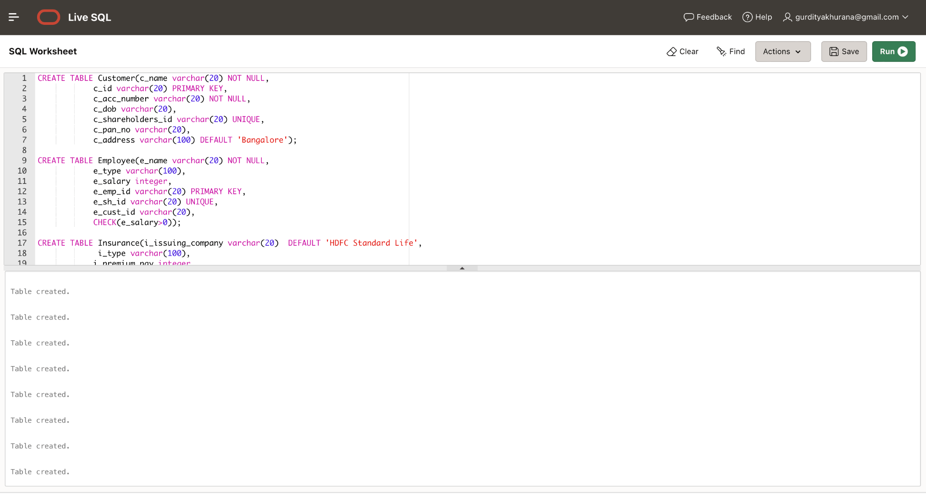

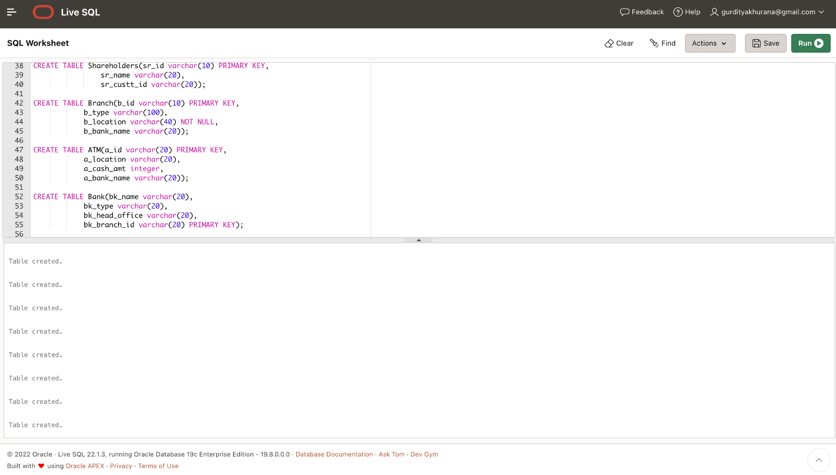

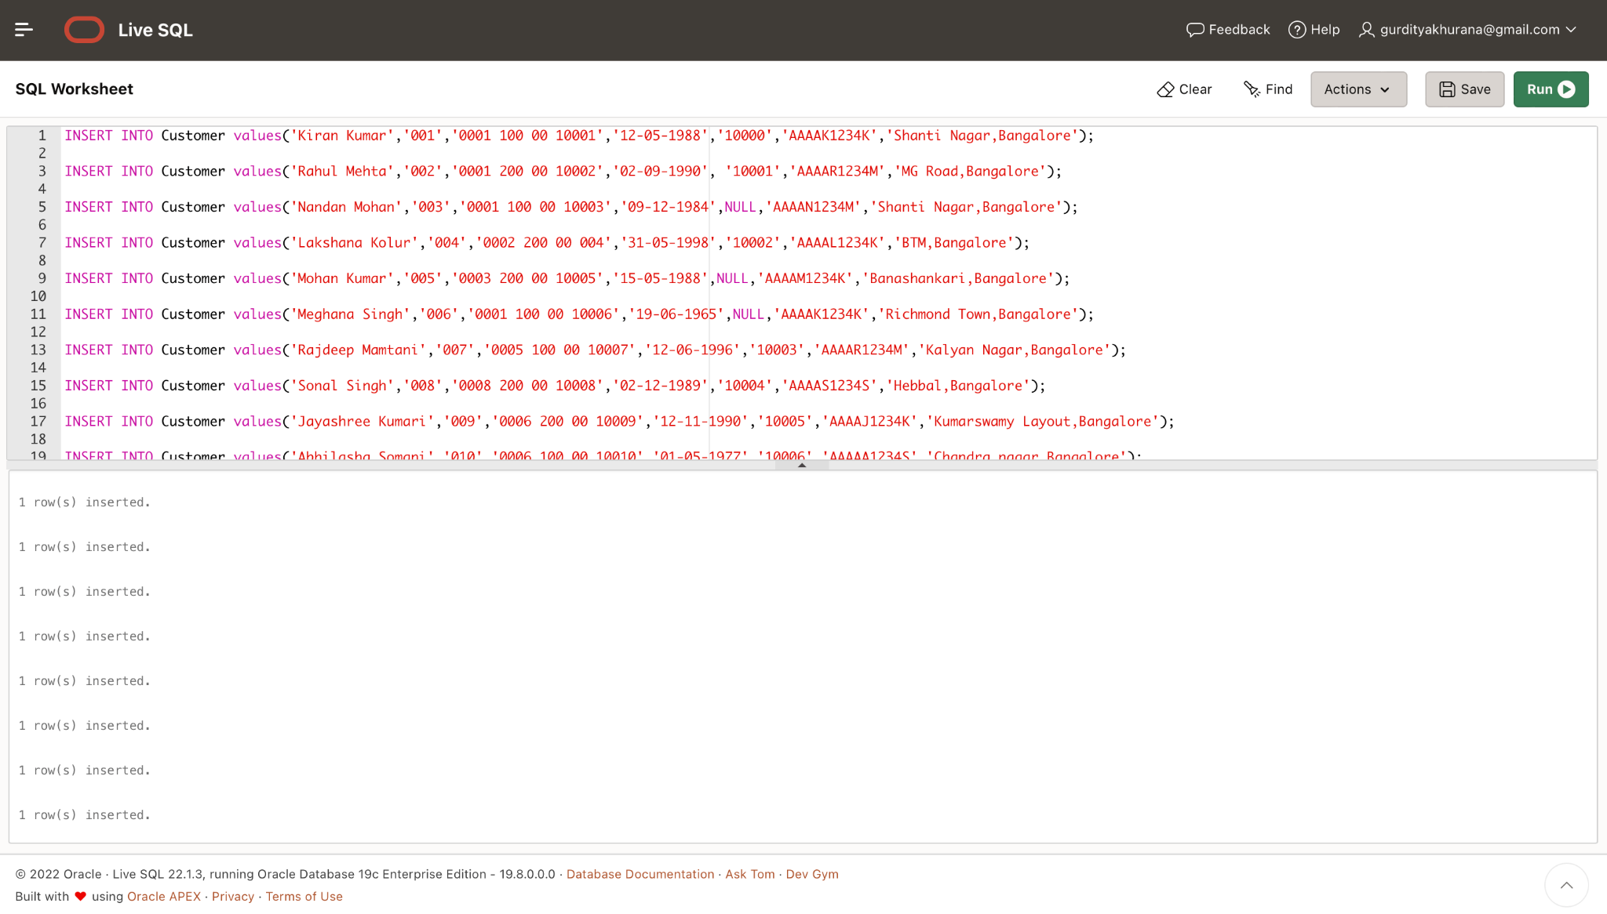

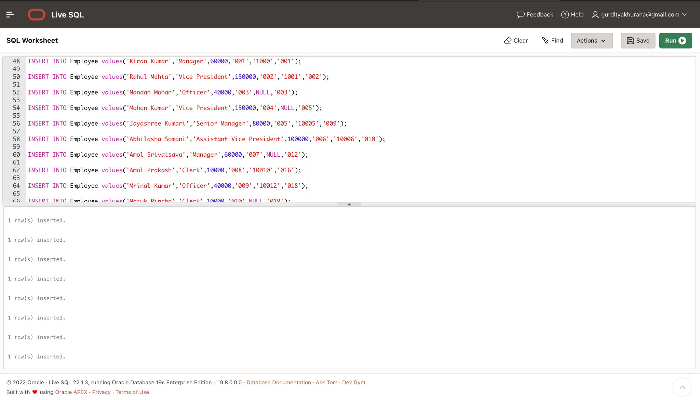

REFERENCES

[1] <https://itsourcecode.com/uml/bank-management-system-er-diagram-entity-relationship-diagram/>